Architectural Model

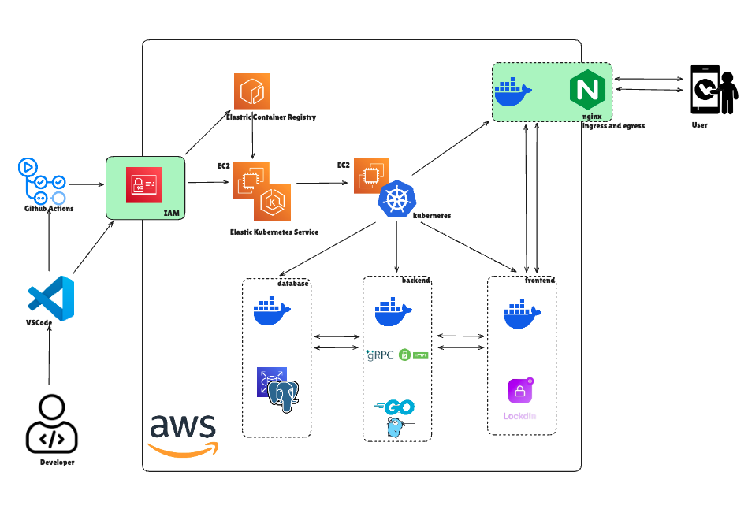

We deploy LockdIn on AWS using a Kubernetes (EKS) cluster, with an external Application Load Balancer (ALB) or Network Load Balancer routing traffic to an NGINX Ingress controller. The ALB (or equivalent AWS LB) performs TLS offload using ACM-managed certificates, terminating HTTPS and handshaking with clients . The NGINX ingress then load-balances incoming HTTPS requests to the frontend service pods within the cluster. This design offloads encryption work to the ingress layer for better performance . Frontend pods (Docker containers in EKS) serve as the public API gateway or web UI, handling request parsing and authentication. They relay data internally via gRPC to backend service pods; gRPC (with protobuf) is used for high-performance inter-service communication . Backend pods (Go/gRPC services) implement core logic (usage tracking, rule evaluation, notifications). A PostgreSQL database (Amazon RDS/Aurora) stores user settings, usage events, aggregates, and lockdown rules. CI/CD is automated with GitHub Actions: on code push, Actions build Docker images, push them to a private ECR, and update the EKS deployments. All AWS resources (nodes, pods, IAM roles) follow least-privilege: each pod has an assigned IAM role limited to needed operations .
- Components: The NGINX Ingress controller terminates TLS (using ACM certificates) and routes traffic internally. Frontend pods handle public API endpoints and validate requests. Backend pods run the Usage Aggregator, Rule Evaluator, and Notification Dispatcher. A managed PostgreSQL (RDS/Aurora) holds data (encrypted at rest via AWS KMS ). GitHub Actions (with OIDC/IAM roles) updates container images in ECR and applies Kubernetes manifests.
- Data Flow: A user’s mobile app issues HTTPS requests (e.g. post usage events, fetch analytics). Traffic first hits the AWS LB and TLS is terminated at the NGINX ingress. The ingress forwards the request to the appropriate frontend service pod. The frontend validates input and invokes the corresponding backend service over gRPC. The backend then reads or writes to the Postgres DB as needed. For example, a POST /api/v1/usage event is processed by the Usage Engine, which normalizes the data and updates daily/weekly aggregates in the DB. A GET /api/v1/analytics request causes the Usage Engine to query aggregated stats and return a JSON summary. All channels use encryption (TLS for client-to-ingress; mTLS or TLS for internal gRPC as needed).
- Security Controls: We follow AWS best practices for containerized services. All external API endpoints require HTTPS with TLS (terminated at the NGINX ingress using ACM certs) . Container images reside in a private ECR registry with automated vulnerability scanning enabled. Each pod runs with a minimal IAM role (e.g. the backend has only permissions to access its database and SNS/SES, nothing extra) . Kubernetes NetworkPolicies can optionally be applied to restrict pod-to-pod traffic (allowing only needed connections) . The PostgreSQL database is encrypted at rest via AWS KMS (all storage, backups, and snapshots are encrypted ). Data in transit (between app/backend) is encrypted via TLS/SSL (e.g. enabling rds.force_ssl for Postgres ). We minimize data retention: only aggregated usage metrics are stored (in line with GDPR/data-minimization principles ) and older data is periodically purged or rolled up. All data handling adheres to a documented privacy policy, with retention limits as required by regulation.
- Platform Constraints: The mobile clients implement platform-specific lockdowns. On Android, we use the Device Admin or Usage Access APIs to enforce hard locks, so that apps are actually blocked at runtime (fulfilling non-bypassable lockdown requirements). On iOS, we use Apple’s Screen Time/DeviceActivity APIs to issue soft limits (reminders or overlays), since iOS does not allow third-party apps to forcibly block other apps. The client apps (Android and iOS) incorporate these behaviors: Android triggers a lockdown intent when limits are reached, while iOS simply notifies the user. The backend rule engine emits either a “lock” action (for Android) or “notify” action (for iOS) based on the platform.
- Privacy & Data Minimization: From design, we collect only necessary usage metadata (app identifiers, durations, timestamps) and minimal user identifiers, always with explicit user consent . Raw logs are never stored unaggregated; instead, the Usage Engine updates roll-up counters (e.g. daily totals per app) so that only summaries are persisted. Wherever possible, data is kept on-device (the app can compute some aggregates locally and only send summaries). This “privacy-by-design” approach aligns with data-minimization principles: personal data is “adequate, relevant and limited to what is necessary” . All permissions and data uses are clearly explained in first-run screens and settings (consent-first design).

User Interface Model (Front End)
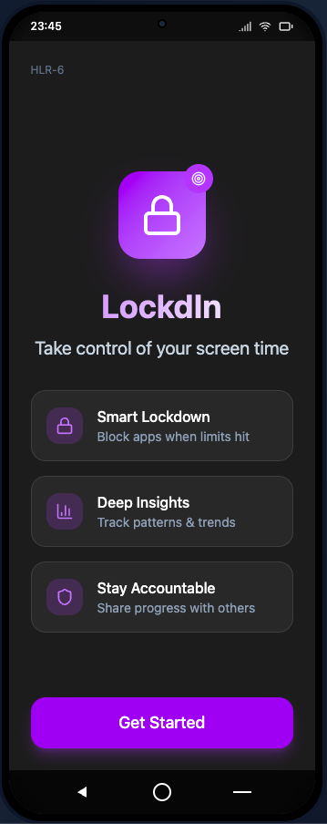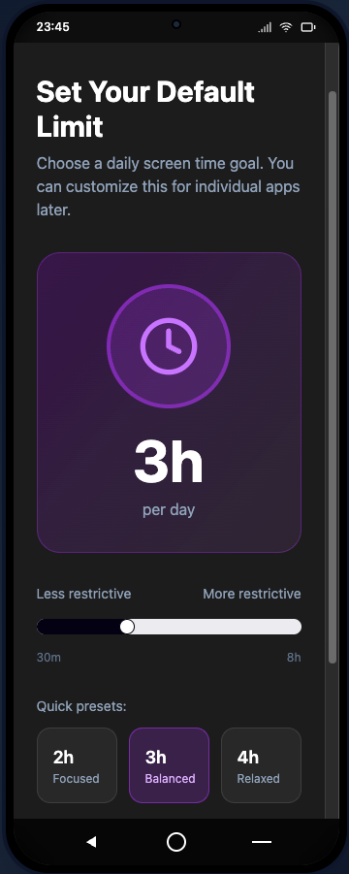
LockdIn provides native mobile apps for Android and iOS (and an optional web UI) that focus on usability and accessibility. The apps offer an intuitive onboarding flow (≤2 minutes setup) that requests only necessary permissions and explains data usage clearly (meeting quick-start goals). The main UI features include:
- Analytics Dashboard: A visual summary of screen time and app usage, showing daily/weekly totals, top used apps, and usage patterns (e.g. peak hours). Users can drill into categories and time ranges. This fulfills requirements for behavioral insights (HLR-3, HLR-10). The dashboard uses charts and lists with clear labels.
- Rule Setup & Settings: Screens where users define custom lockdown rules (e.g. “limit Instagram to 2 hours/day”). The UI lets users select apps or categories and set timers. Separate sections allow choosing notification tone profiles (HLR-4) and managing accountability contacts (HLR-5). All settings follow a clean, accessible layout (large touch targets, logical grouping).
- Onboarding & Consent: On first launch, the app presents an onboarding wizard that explains its purpose (“digital well-being tool”), asks for necessary permissions (e.g. usage access or device admin on Android), and obtains consent for data collection . This respects privacy requirements (HLR-15) by being explicit about what is collected and why.
- Notifications UI: When limits are reached, the app displays a lock screen (Android) or alert (iOS) with the configured message/tone. Users can also trigger manual notifications to accountability contacts. Tone and reminder templates are user-selectable in settings.
- Accessibility: The app is designed to meet WCAG 2.1 AA standards for mobile apps . For example, it uses high-contrast colors, scalable fonts, and accessible labels. The interface supports screen readers and keyboard navigation where applicable. UI elements are sized for touch and laid out for readability (WCAG 2.1’s mobile criteria for “small screen sizes” and contrast) .
Overall, the front-end design emphasizes a friendly user experience (HLR-12) with clear calls-to-action (lock now, view stats, set limits) and inclusive design. The mobile UI is distinct on Android vs. iOS to match each platform’s conventions, but core flows (analytics, rule creation, notifications) are consistent across both.

Algorithmic Model (Back End)
Our back-end consists of microservices (Go/gRPC) that implement the core algorithms. Major components include:
- Usage Tracking & Aggregation Engine (HLR-1, HLR-3): This service ingests usage events from clients and maintains aggregated stats.
  - Input: JSON events like {userId, appId, timestamp, durationSeconds, location?, category?} sent by the mobile app.
  - Processing: Each event is validated (check user permissions, app ID) and inserted into Postgres. The engine updates rolling aggregates (daily/weekly screen time per app or category). Background jobs compute trends (peak usage hours, location-based patterns) for insights.
  - Output/API: Provides endpoints such as GET /api/v1/analytics?userId=XYZ that return a JSON summary (fields like todayTotal, weeklyTrend, topApps[], peakHours[]). This is used by the front-end to display charts.
  - Sample API:
# Post a usage event
curl -X POST https://api.lockdin.example.com/api/v1/usage \
-H "Content-Type: application/json" \
-d '{"userId":"1234","appId":"com.social.app","duration":600,"timestamp":"2025-11-02T18:23:00Z"}'
# Get aggregated analytics
curl https://api.lockdin.example.com/api/v1/analytics?userId=1234

  - Errors: The API returns 4xx for bad requests (missing fields, malformed JSON), 404 if the user is unknown, and 500 on server/DB errors. If a new user has no data, the analytics endpoint returns zeros or empty lists.

- Rule Evaluator & Lock Enforcer (HLR-2, HLR-13, HLR-14): This service applies user-defined limits and issues lock/notify actions.
  - Input: Periodic usage updates or events from the app (e.g. “user X has used app Y for Z seconds today”) plus the user’s configured rules from the database (e.g. “max 2h/day on Instagram”).
  - Processing: For each update, it fetches relevant rules and compares usage to limits. If usage ≥ limit, it triggers the appropriate action. On Android, it sends a lock command (via push notification or gRPC callback) so the client calls the device admin API to block the app. On iOS, it instead sends a reminder/alert message (since true enforcement isn’t allowed). The service logs lock events for auditing.
  - Output/API: Returns a JSON action for the app. Examples include {"action":"lock","apps":["Instagram"],"message":"Time’s up!"} for Android, or {"action":"notify","message":"Reminder: limit reached!"} for iOS. If under limits, it returns {"action":"ok"}.
  - Sample API:
curl -X POST https://api.lockdin.example.com/api/v1/checkLimits \
-H "Content-Type: application/json" \
-d '{"userId":"1234","appId":"com.social.app","usageSecondsToday":7200,"timestamp":"2025-11-02T20:00:00Z"}'

  - Errors: Returns 400 if required fields are missing, 404 if no rule exists (treated as no action), or 500 on internal errors. If rule lookup fails (e.g. DB down), it responds {"action":"error","message":"Try again later."}.

- Notification & Accountability Dispatcher (HLR-4, HLR-5): This service sends messages when limits are hit or on schedule.
  - Input: Triggers from the Rule Evaluator (limit exceeded) or scheduled tasks (daily/weekly summaries). It also reads user settings (notification tone profile, opted-in contacts for accountability).
  - Processing: It formats a message according to the chosen tone (e.g. “Time’s up!” vs. “Reminder: almost at your limit!”). If the user enabled accountability, it sends an email/SMS report to the chosen contact; otherwise it only sends a push notification to the user. The dispatcher records each sent notification in the DB for history.
  - Output/API: Initiates delivery via push or email/SMS. The service API returns success status, e.g. {"status":"sent","detail":"Notification delivered."}.
  - Sample API:
curl -X POST https://api.lockdin.example.com/api/v1/notify \
-H "Content-Type: application/json" \
-d '{"userId":"1234","tone":"edgy","type":"limitExceeded","contactEmail":"friend@example.com"}'

  - Errors: Returns 400 if parameters are missing, 404 if user/contact not found, 429 if rate limits exceeded, 500 if the notification service fails. Bounced emails are logged for retry or disabling that contact.
Each component above is linked to our high-level requirements (see traceability below). Together, the algorithmic services implement the business logic: tracking usage, enforcing rules (hard-lock on Android, soft notify on iOS), and dispatching notifications, all while respecting user preferences and privacy.

Requirements Traceability
We ensure every high-level requirement (HLR) is covered by our architecture:
- HLR-1 (Usage Monitoring): Satisfied by the Usage Tracking & Aggregation service (backend) which records daily/weekly totals, and by the mobile analytics dashboard (front end).
- HLR-2 (Custom Lockdown Rules): Addressed by the mobile app’s rule-setup UI and the backend Rule Evaluator (plus Android Device Admin API for enforcement).
- HLR-3 (Behavioral Insights): Provided by the backend analytics engine (computing trends/locations) and the analytics UI in the app.
- HLR-4 (Notification Tone Profiles): Implemented via the app’s settings UI (tone selection) and the backend Notification Dispatcher (which uses tone templates).
- HLR-5 (Accountability Contacts): Covered by the app’s contact-management UI and the backend dispatcher, sending reports to user-specified contacts.
- HLR-6 (Quick Onboarding): Met by a streamlined mobile app UX with clear instructions and consent prompts, ensuring setup in under 2 minutes.
- HLR-7 & HLR-18 (Accessibility): The mobile UI follows WCAG 2.1 AA guidelines (e.g. readable text, color contrast, screen-reader support).
- HLR-8 (Screen Time Reduction): An outcome metric tracked by the backend analytics (used to evaluate product success).
- HLR-9 (User Retention): Measured via analytics (app launch and usage events captured by backend).
- HLR-10 (Analytics Views): Supported by the app’s analytics screen and the backend API that serves analytics data.
- HLR-11 (Accountability Enablement): Driven by the settings UI (to opt in) and the backend dispatch (to send alerts).
- HLR-12 (Satisfaction ≥4.0): Achieved by focusing on polished UI/UX in the mobile app (responsive design, intuitive workflows).
- HLR-13 (Android Lockdown): Implemented by the Android client (using DeviceAdmin or LockTask APIs) and the backend rule engine triggering locks.
- HLR-14 (iOS Soft Limits): Implemented by the iOS client (using ScreenTime/DeviceActivity APIs) and backend notifications.
- HLR-15 (Data Minimization & Consent): Enforced by only collecting minimal usage metadata (mobile app consent screens) and by backend policies that store aggregated data only .
- HLR-16 (<5% Crash Rate): Ensured via robust app development and automated backend monitoring (crash analytics).
- HLR-17 (Privacy & Retention): Handled through the mobile privacy settings UI (user controls) and backend data management (automatic roll-ups and purges).

Societal Impact & Ethics (IE.2)
LockdIn is designed to have positive social impact by combating digital distraction. Excessive smartphone use has been linked to reduced concentration, increased stress and anxiety, and lower productivity . For example, medical experts note that constant digital interruptions “fragment our cognitive processes, leading to decreased productivity and increased stress” . By enforcing usage limits and encouraging mindful device use, LockdIn helps users reclaim time for offline activities and focus on what matters, aligning with our goals of “healthier screen habits” and improved well-being.
Ethically, we prioritize privacy-by-design. We collect only what is necessary: anonymized usage counts and app identifiers, never personal content or raw logs. This aligns with data-minimization principles (e.g. GDPR’s rule that data must be “adequate, relevant and limited to what is necessary” ). All data collection is explicit and opt-in: users consent to provide usage access or device admin rights when they install the app. Usage data is stored in aggregated form, and we implement strict retention policies (data is purged or rolled up after use). Accountability features are strictly opt-in: users must explicitly add a contact before any report is shared. All data transmissions and storage are secured (encrypted) and fully documented. In sum, LockdIn delivers real benefits (less distraction, better habits, higher productivity) while respecting autonomy and privacy: we operate with transparency, limit data to the bare minimum , and give users control over their information (consistent with our charter’s privacy commitments).
Sources: Our design follows AWS/Kubernetes best practices for architecture and security . We use cloud-native patterns (Ingress controllers, managed databases) and adhere to AWS security guidelines (TLS, encryption, least-privilege IAM) . Accessibility and UI design meet established standards (WCAG 2.1 for mobile) . Digital well-being research (e.g. on screen-time impact ) and privacy regulations (GDPR data-minimization ) guided our ethical framework. All content above is based on these principles and up-to-date sources.

